Assessment Outline
Assessment Task: Capstone Project Final report

Title: Payment Fraud Detection
Introduction
This report provides a structured analysis of Irish payment card fraud data to develop effective, data-driven fraud detection models. It begins with data understanding and exploratory data analysis (EDA) to ensure data quality, consistency, and suitability for modelling. Through preprocessing, statistical validation, and feature analysis, the dataset is refined to generate reliable insights.
The report then evaluates multiple machine learning models, including Logistic Regression, Random Forest, and XGBoost, to measure their effectiveness in detecting fraudulent activity. Key challenges such as class imbalance, feature relevance, and model interpretability are also examined.
In addition, strategic frameworks such as SWOT and PESTLE are used to place findings within wider organisational, economic, and technological contexts. Legal and ethical considerations, including GDPR and the EU AI Act, are also addressed to ensure responsible and compliant use of data and AI. Overall, the report aims to improve fraud detection while maintaining transparency, reliability, and practical value for financial institutions.

Strategic overview
To tackle rising payment fraud, the strategy focuses on data-driven detection using machine learning. High-risk features, Transaction Channels, Geographic Area, Payment Card Types, SCA Classification, Transaction Type, and Confidentiality Flag, are prioritized for monitoring and modelling. Tree-based and ensemble models will capture multivariate fraud patterns, while data preprocessing addresses skewness, imbalance, and low-value features. Continuous model updates and integration with fraud monitoring processes will ensure proactive, adaptive prevention, reduce losses and strengthen customer trust.
Project Plan
- Data collection: Source the Irish payments fraud statistical dataset from data.gov.ie
- Data Cleaning and preprocessing: handle any missing values, normalise features, create derived features by using Python (programming language)
- Exploratory Data Analysis ( EDA): Descriptive analysis, visualisation of fraud and no fraud patterns, examinate class imbalance, examinate correlations, identify potential predictor features, prediction, Chi-squared statistics
- Data Engineering, Encoding, scaling
- Statistical analysis (Bayesian theory, Shapiro-Wilk Test, T-statistic, ANOVA, Levene test etc.)
- Model development: Traditional ML models ( logistic regression, random forest, KNN, Linear regression, etc.. )
- Model Evaluation: Report accuracy of each model, comparisons
- Documentation and presentation: Final report covering all literature review, methodology, result, business insight, limitation, future work and power point presentation
Business understanding
The shift to digital payments has increase fraud risk, creating financial and reputation threats. Traditional rule-based systems are ineffective, requiring data-driven, machine learning approaches for accurate fraud detection.
Data understanding
- Data Structure Overview
The dataset contains 226,678 records and 33 variables, covering aggregated payment statistics for Ireland from mid-2022 to end-2024. Values are mainly in millions of euros, with some count-based measures, and the dataset is about 57.1 MB in size.
The main numerical variable, OBSERVATION, has 59% missing values and is highly right-skewed, with a high mean (179.35) but a near-zero median. This indicates strong non-normality and suggests the need for log transformation or non-parametric methods.
The RL_TRNSCTN variable is binary with a 75% imbalance toward one class, making it more suitable for categorical or proportion-based analysis.
Overall, the data is highly aggregated, with many broad or “not applicable” categories dominating, including geography, payment channels, and fraud type. More than 60% of records are flagged as confidential, reinforcing its summary-level structure.
In general, the dataset represents macro-level payment statistics rather than individual transactions, requiring careful use of transformations and categorical methods for analysis.

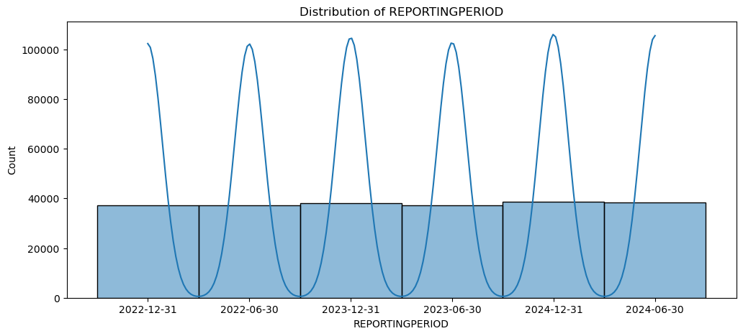
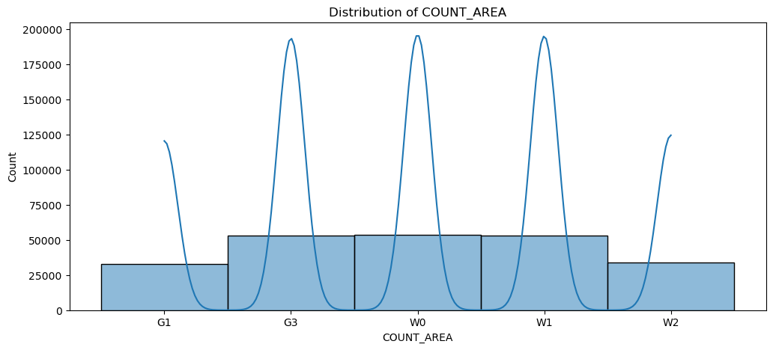
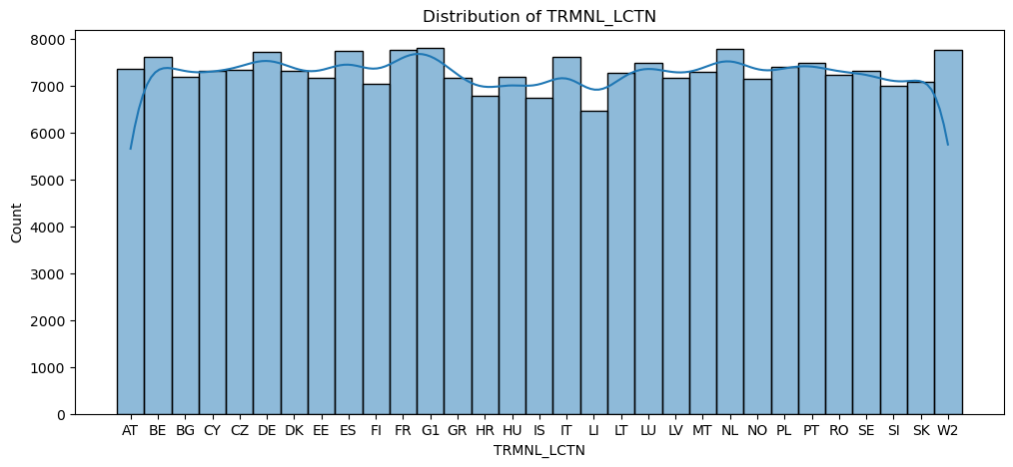
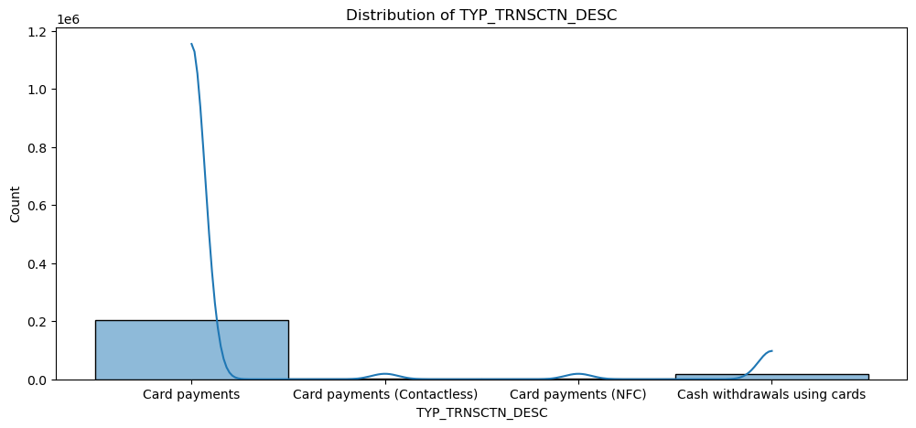
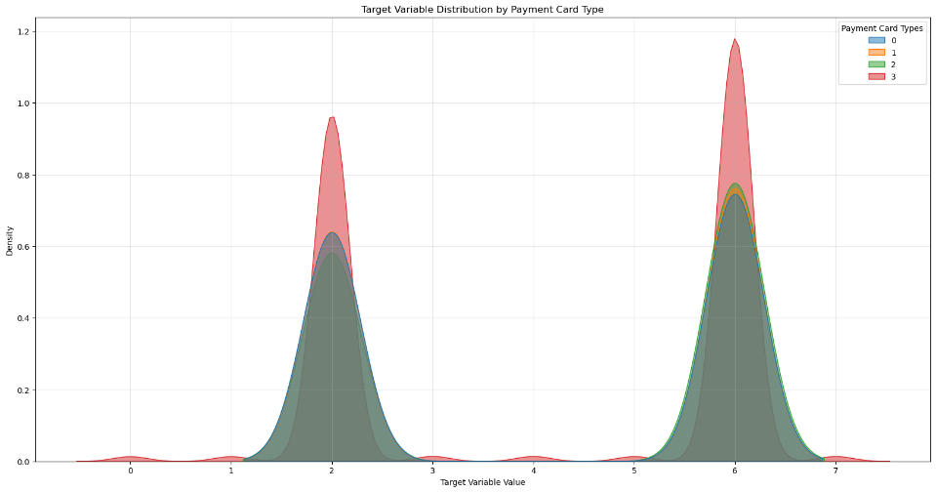
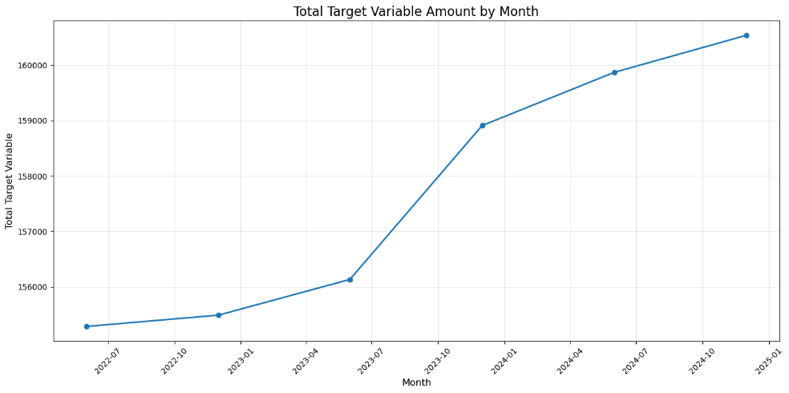

- Outlier removal impact Summary
The dataset originally contained 226,678 records, which was reduced to 111,180 after outlier removal—an elimination of about 51%. This suggests an aggressive filtering approach likely driven by categorical patterns rather than extreme numerical values.
The transformed “Observation” variable retained the same range before and after cleaning, indicating that outliers were defined by combinations of categorical attributes rather than numerical extremes.
Outlier removal had a major impact on categorical variables, with many transaction types, channels, and card categories being largely eliminated. In several cases, only dominant categories remained, including significant changes to transaction types and Strong Customer Authentication (SCA) classifications. Time-related variables remained unchanged, showing that filtering was not time-based.
Overall, removing over half the dataset risks losing meaningful transaction diversity and potentially important fraud-related patterns. As a result, the full dataset will be retained for analysis and machine learning.

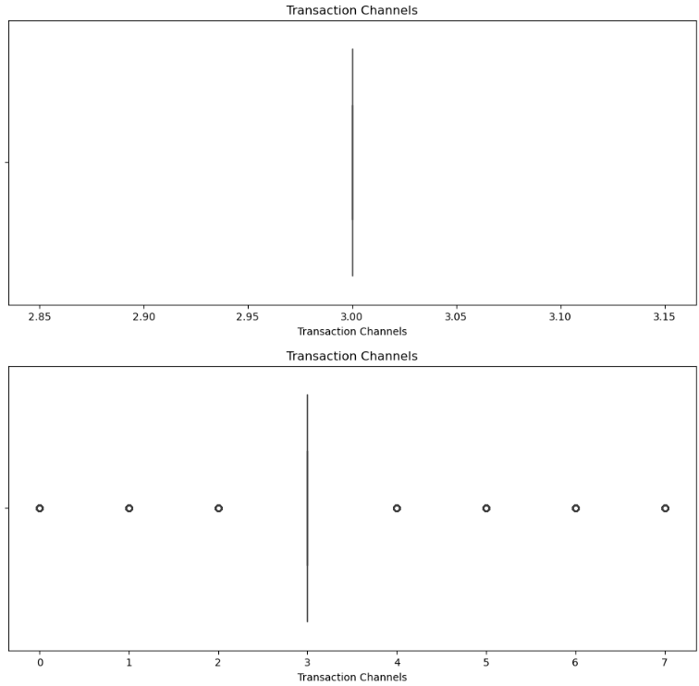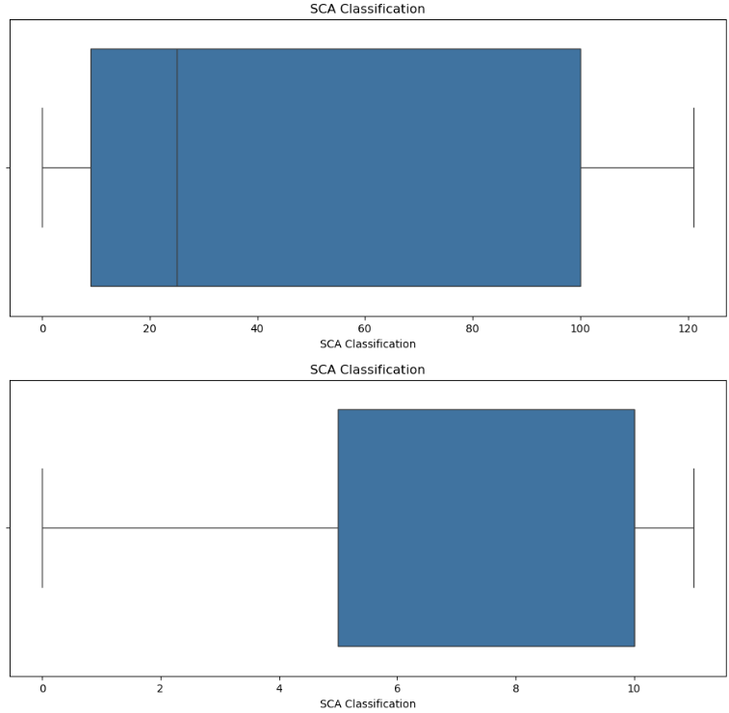

- Statistical analysis
The Bayesian analysis shows that fraud risk in the dataset is highly structured and concentrated in specific feature combinations rather than being randomly distributed.
Payment Card Type 9 stands out as the strongest risk factor, as it is linked to all fraud categories, while other card types are mostly associated only with general fraud or non-applicable cases. At the geographic level, W2 (Unknown/World 2) has the highest fraud rate (49.5%) and a more varied fraud distribution compared to most European countries, which show very limited variation. Strong Customer Authentication (SCA) Classification 100 shows a similar pattern to Card Type 9, being associated with all fraud types, while other SCA categories are much more restricted. Overall, Fraud (Code 2) and Not applicable (Code 6) dominate the dataset, making up over 90% of records. These strong and repeated patterns suggest deterministic relationships rather than probabilistic ones, likely caused by data design or aggregation issues. As a result, while certain high-risk combinations can be identified, the structure of the data limits the reliability of Bayesian inference for real-world fraud prediction.
The chi-square analysis examines relationships between fraud types and key categorical features, revealing several significant patterns. The strongest association is with Transaction Channels (V = 0.1909), indicating clear variation in fraud distribution across channels. Geographic Area also shows a weaker but meaningful relationship (V = 0.0810). SCA Classification (V = 0.0554) and Payment Card Types (V = 0.0523) have statistically significant but weak associations, while Country shows a very small effect (V = 0.0133). In contrast, time-based variables (quarter and month) and payment scheme show no significant relationships (p ≥ 0.999), suggesting stable fraud patterns over time and across schemes. Overall, Fraud Type 2 and Not applicable Type 6 dominate the dataset (~95%), with minor fraud types appearing only in specific combinations of channels, card types, and SCA classifications. This suggests limited natural variation and possible data structuring effects.
The results indicate that transaction channels, geographic area, SCA classification, and card type are the most relevant factors for fraud differentiation, while temporal and scheme-based features add little predictive value.
The histogram and Q–Q plot analysis highlights the dataset’s distributions and several data quality issues. Some variables show approximately normal distributions, including Confidentiality Flag, Country Origin, Geographic Area, Country, Transaction Channels, and Transformation Description, suggesting potential suitability for parametric methods.
In contrast, Payment Scheme, Year, Quarter, Month, and Day show uniform distributions with limited variability, reflecting a restricted time range and limiting trend or seasonality analysis. Payment Scheme shows no variation at all, making it uninformative. Payment Card Types and the target variable are highly right-skewed, with fraud codes 2 and 6 dominating, indicating strong class imbalance. Other variables, including Transaction Type, Transaction Description, SCA Classification, and Unit Measure, show bimodal or multimodal distributions, suggesting multiple underlying groups. The Transaction variable is highly discrete and non-continuous, as shown by its stair-step Q–Q plot, indicating heavy encoding and limited analytical value.

Overall, the analysis highlights class imbalance, low variability, discretisation, and limited temporal coverage. These issues require careful preprocessing such as transformation, balancing, or feature removal. Tree-based and non-parametric models are more suitable for these characteristics in practice and applied settings.
Despite this, Transaction Channels, Geographic Area, Country, and Payment Card Types remain strong candidates for fraud analysis, while Payment Scheme, Transaction, and some temporal features should be used cautiously or excluded.

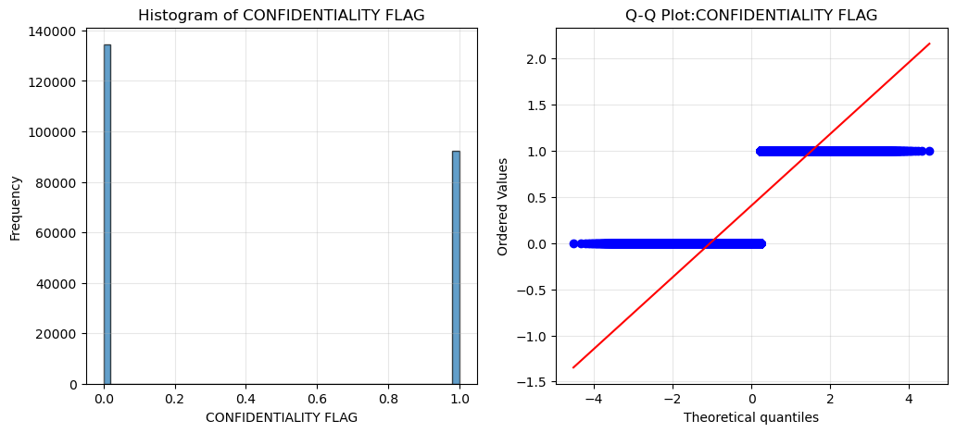
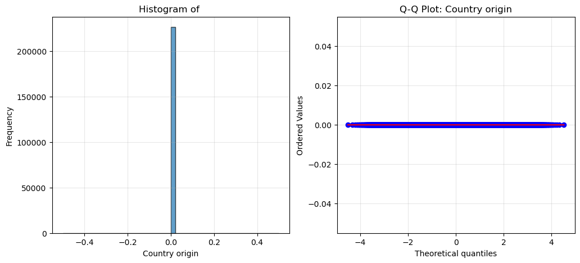
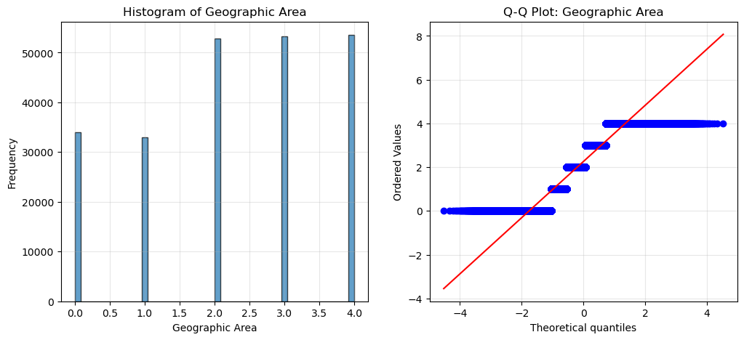
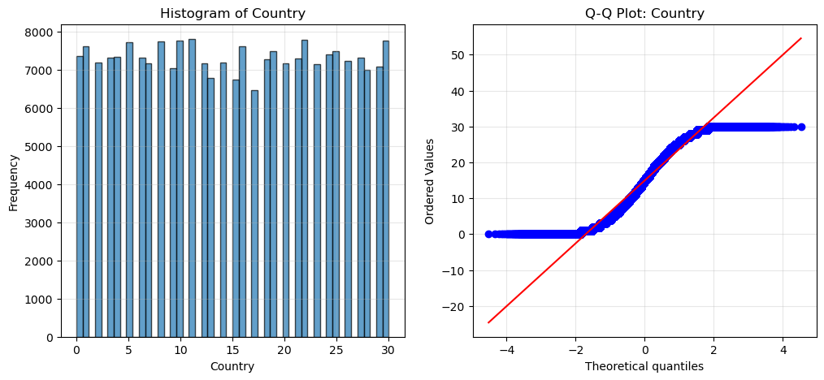
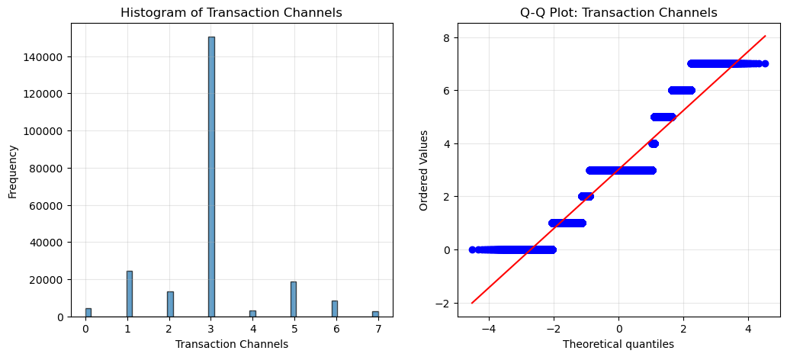
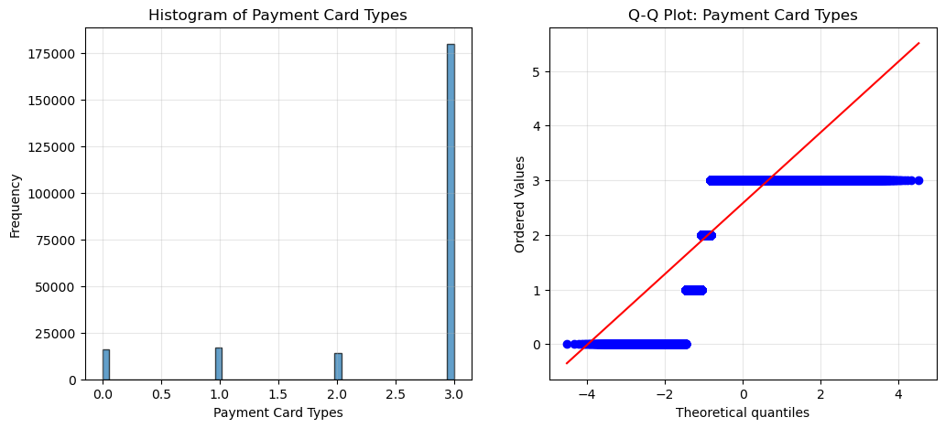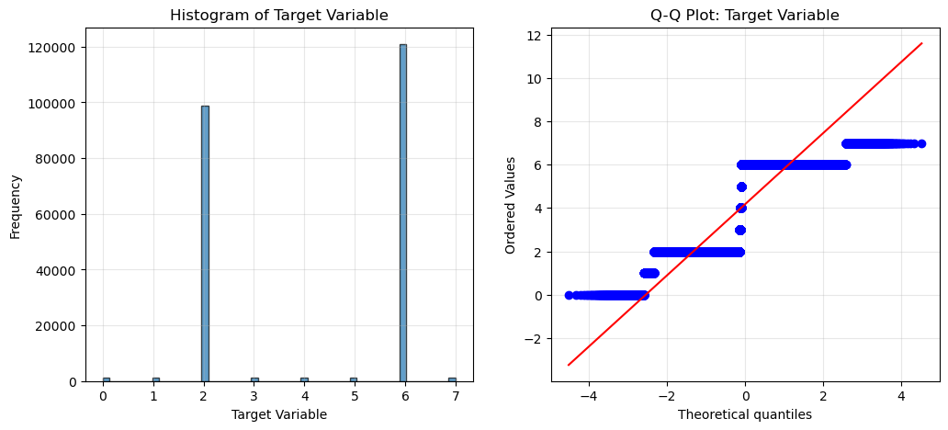

The Shapiro-Wilk test was applied to 18 key variables to assess normality. Four variables—likely UNITS, Country origin, Transaction Descriptions, and Transformation Description—showed perfect normality and are suitable for parametric tests. The majority of variables, however, are non-normal. The Transaction variable is extremely non-normal, confirming histogram observations of severe skew and likely heavy transformation. Transaction Channels, Payment Card Types, SCA Classification, Payment Scheme, and the time variables (year, month, quarter, day) are also non-normal, with some appearing deceptively normal in histograms. Borderline non-normal variables include Geographic Area, Country, Transaction Type, and Unit Measure. These results indicate that non-parametric tests are appropriate for most variables, while tree-based models are well-suited for predictive modelling. Linear models and neural networks may require transformations for stability. Variables such as Transaction Channels, Geographic Area, Payment Card Types, and SCA Classification are high priority due to both statistical significance and predictive potential, whereas Payment Scheme and the Transaction variable may be problematic. Overall, the dataset is predominantly non-normal, which is typical for fraud-related data, and careful method selection and preprocessing are essential.
The one-sample T-test shows that some variables, like Confidentiality Flag and Transaction Type, have non-zero means but appear non-significant, likely due to large sample effects. Significant predictors include Geographic Area, Transaction Channels, Payment Card Types, SCA Classification, Country, and time variables, while the Target Variable mean is 4.17 (codes 2 and 6 dominate).
The Anova results identify three highly significant predictors of fraud. The confidentiality flag is the strongest, with flag 0 transactions showing a 36,8% higher fraud rate than flag 1. Transaction Type is also important: Type 0, 1 and 2 have high fraud rates, while type 3 is significantly saver. Country shows moderate effects, with Croatia, Iceland and Slovenia at the highest risk, and the Netherlands and France at the lowest risk. For fraud prevention, focus on Confidentiality Flag 0, investigate why type 3 is saver, and target high-risk countries. These features should be prioritized in models and business strategies.

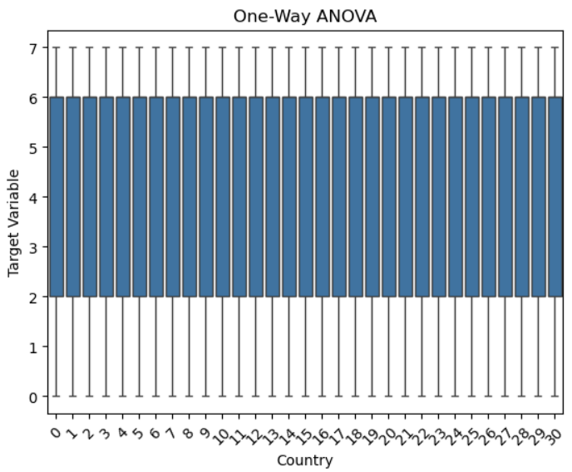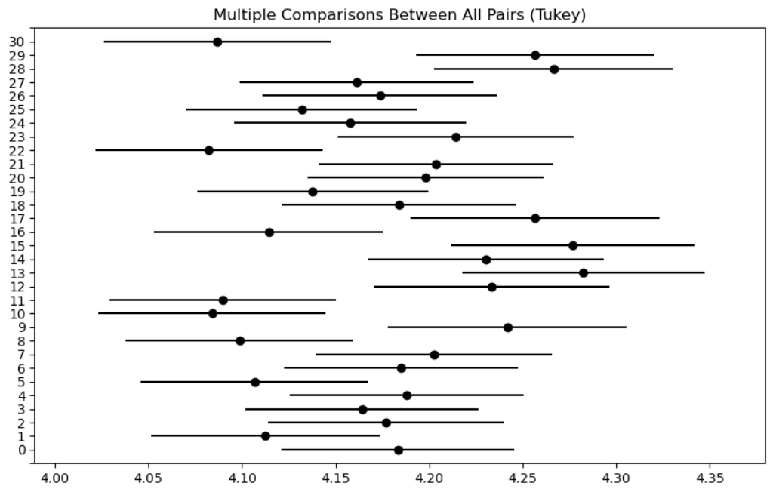

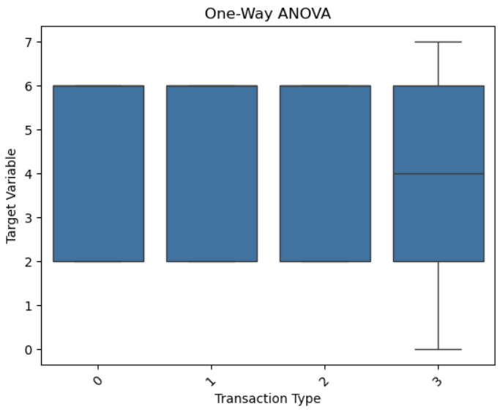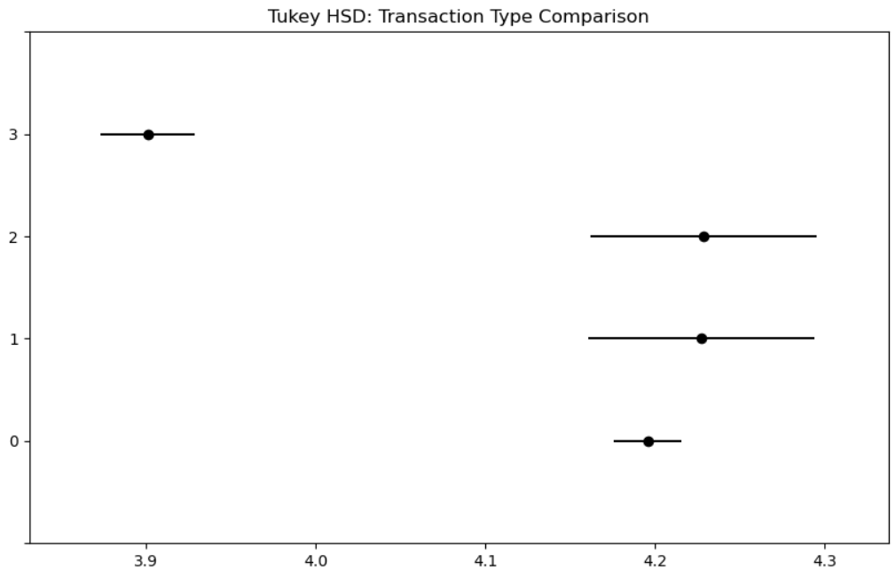

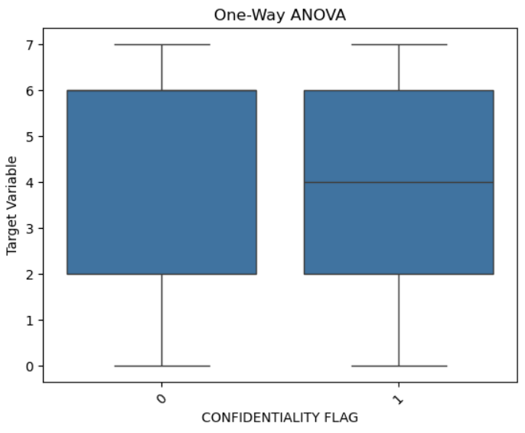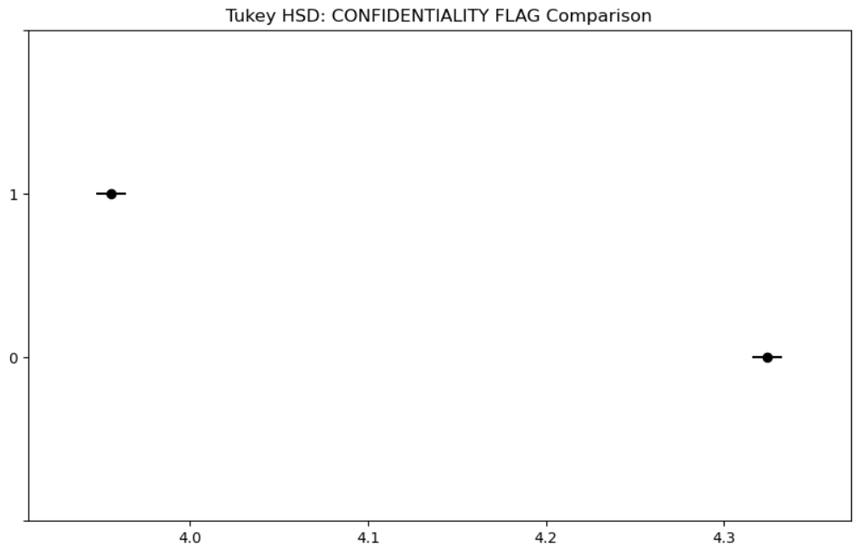

The correlation matrix shows weak direct relationships with the target, though multivariate patterns are evident. Strongest feature correlations include Transaction Type with Transaction Channels (-0.48) and Transaction Decs (-0.50), Transaction Decs with SCA Classification (-0.29), and Payment Card Types with SCA Classification (-0.28). Geographic Area correlates positively with Confidentiality Flag (0.28). Correlations with the target are weak (highest: Confidentiality Flag, -0.09). Constant variables—UNITS, Country origin, Payment scheme, and TRANSFORMATION DESC—can be removed. Temporal features are perfectly collinear, so only one should be used. Fraud-relevant features (Transaction Channels, Geographic Area, Payment Card Types, SCA Classification) show multivariate rather than univariate effects. Transaction Type and Transaction Decs dominate feature-feature correlations, with the Transaction variable showing unusual patterns. Overall, tree-based or ensemble models are recommended, as single-variable correlations are too weak for fraud prediction.

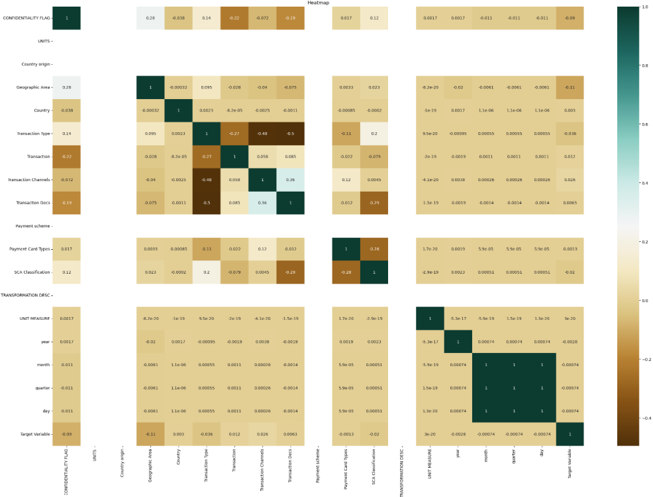

Data preparation
For data preparation, three datasets were combined and 17 repetitive variables were removed. The date variable has been split into Year, Quarter, Month and Day. Fifteen categorical variables were converted to integers using Label Encoding and StandardScaler, avoiding one-hot encoding to prevent excessive columns. Skewness was checked, and three highly skewed variables were transformed.
- Enhancements’
A key enhancement in my approach was the implementation of a skewness analysis framework to guide preprocessing decisions. Most numerical features exhibit skewness values close to zero, indicating approximate symmetry and, therefore, no strong need for transformation. Variables such as UNITS, Country of Origin, Country, Payment Scheme, Transformation Description, Unit Measure, and temporal components (year, month, quarter, and day) demonstrate near-symmetric distributions. Transaction Amount and Transaction Channels display only mild skewness; while the application of a logarithmic transformation may be beneficial for normalization, it is not strictly necessary. In contrast, three variables—Transaction Type, Payment Card Types, and SCA Classification—show high skewness values (2.85, −1.97, and −1.26, respectively). However, these variables are categorical in nature and have been numerically encoded. Consequently, their observed skewness is an artifact of the encoding process rather than a reflection of genuine distributional imbalance. The application of one-hot encoding, rather than logarithmic transformation, is therefore methodologically appropriate. Finally, the target variable exhibits an approximately symmetric distribution, which is suitable for modelling purposes. To ensure consistency and reproducibility, I implemented an automated skewness-based transformation procedure, where numerical variables with high skewness (|skew| > 1) were normalised using a logarithmic transformation. This approach reduces the impact of outliers and non-normality while standardising preprocessing across the dataset. However, I also critically evaluated this automated process, recognising that it may incorrectly flag categorically encoded variables; these cases were subsequently handled using appropriate encoding techniques rather than transformation. Overall, my EDA evolved from basic data exploration to a more strategic and methodologically justified process, where preprocessing decisions were guided by statistical evidence. This improved understanding of the data directly supports more robust feature engineering, enhances model readiness, and ultimately contributes to more reliable and interpretable modelling outcomes.

SWOT and PESTLE
- Strengths
A key strength of this work is the structured and methodical EDA process, which shows a clear understanding of the dataset’s composition and data types. Descriptive statistics, correlation analysis, and visualisation techniques helped identify meaningful patterns and relationships within the data. The use of a skewness-based preprocessing strategy also demonstrates strong analytical thinking, ensuring transformations were applied where appropriate. In addition, distinguishing between true numerical variables and encoded categorical features strengthens the validity of the preprocessing process and supports improved model performance.
- Weaknesses
Despite the robust approach, some limitations remain. The automated skewness-based transformation process may incorrectly identify encoded categorical variables, requiring manual review and additional validation. While the EDA highlights relationships and distributions, limited domain-specific interpretation of certain features may restrict deeper insights. In addition, some preprocessing decisions, such as transformation thresholds, may introduce a degree of subjectivity.
- Opportunities
There are opportunities to further enhance the analysis by incorporating advanced feature engineering techniques, such as interaction terms or domain-driven feature creation. The use of more sophisticated methods, including dimensionality reduction or feature selection algorithms, could improve model efficiency. Additionally, expanding the analysis to include time-series trends or behavioural patterns could provide deeper insights and strengthen predictive performance.
- Threats
Potential threats include data quality issues, such as hidden biases, incomplete data, or inconsistencies that may not have been fully captured during EDA. There is also a risk that over-reliance on preprocessing techniques (e.g., transformations or encoding) could distort underlying patterns if not carefully validated. Finally, model overfitting may occur if engineered features or transformations inadvertently capture noise rather than meaningful signal.

- Political
Regulatory frameworks surrounding financial transactions and data usage may influence how the dataset can be processed and modelled. Compliance with policies related to data governance and security is essential, particularly when handling sensitive transaction-related information.
- Economic
Economic conditions may impact transaction behaviour patterns within the dataset, potentially affecting model generalisability. Variability in economic activity could introduce shifts in data distributions, requiring models to be adaptable and robust over time.
- Social
User behaviour, preferences, and trust in digital payment systems influence the patterns observed in the data. Changes in consumer habits or demographics may affect feature relevance and require ongoing updates to the model and EDA process.
- Technological
Advancements in data processing, machine learning frameworks, and computational tools support more efficient and scalable EDA and modelling. The use of automated preprocessing techniques, such as skewness-based transformations, reflects the integration of such technologies, though they must be applied critically.
- Legal
Legal considerations include compliance with data protection regulations (e.g., GDPR), particularly when handling transaction and potentially sensitive user data. Proper anonymisation, storage, and processing practices must be maintained throughout the analysis.
- Environmental
While less directly related, the computational resources required for large-scale data processing and modelling may have environmental implications. Efficient data handling and optimisation of preprocessing pipelines can help minimise resource consumption.

Model Design, Optimisation and Comparison
In this study, I compared three machine learning models—Logistic Regression, Random Forest, and XGBoost—to identify the most effective approach for the dataset. These models were chosen due to the mix of numerical and categorical features and the need to capture both linear and non-linear relationships.
The dataset contained 181,342 training samples, 45,336 test samples, and 68 features, making it high-dimensional. The target variable was highly imbalanced, with two majority classes dominating and the remaining classes each representing less than 1%, which significantly affected model performance.

Using 5-fold cross-validation, Logistic Regression achieved 53.02% accuracy, Linear SVM 52.97%, and Random Forest 49.23%, indicating relatively stable but modest performance across models.
On the test set, the models produced the following results:
- Logistic Regression: 52.67% accuracy
- Random Forest: 45.91% accuracy
- XGBoost: 62.05% accuracy
XGBoost outperformed the other models, achieving the highest accuracy, while Random Forest performed the weakest.
To evaluate performance in more detail, I used accuracy and balanced accuracy to account for class imbalance, along with classification reports showing precision, recall, and F1-scores for each class. For Logistic Regression, dominant classes (2 and 6) achieved higher F1-scores (0.56 and 0.55), while minority classes performed poorly, highlighting the impact of imbalance.
A confusion matrix showed that models correctly predicted majority classes but often misclassified minority classes. A comparison of actual versus predicted values further confirmed this pattern.
Despite hyperparameter tuning and cross-validation, performance remained moderate: XGBoost achieved 62% accuracy, Logistic Regression 54%, and Random Forest 50%. This suggests that class imbalance and feature limitations significantly affect results, and further improvements in feature engineering or imbalance handling are needed.

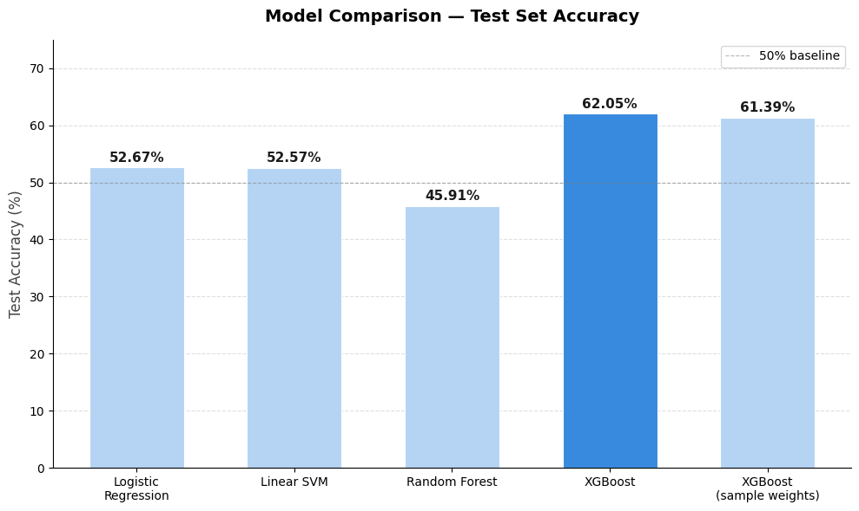

Model Validation and Interpretability
- Statistical Validation Before Modelling
Before model training, statistical tests were used to assess relationships between features and fraud type. Chi-square tests with Cramér’s V were applied to categorical variables. The results showed that Payment Card Type and SCA Classification were significant predictors of fraud type. Payment Card Type had a chi-square value of 1,857.25 (p < 0.0001, V = 0.052), while SCA Classification had a chi-square value of 4,870.55 (p < 0.0001), indicating strong significance. In contrast, quarter and month were not significant (χ² = 0.51, p = 0.999), suggesting no meaningful temporal variation in fraud patterns. Overall, the findings confirmed that several features carried predictive value and were suitable for inclusion in the modelling process.

- Dimensionality Reduction
Following encoding, the feature space expanded to 68 variables, which was reduced using Principal Component Analysis (PCA). PCA identified that 54 components were required to explain 95.84% of the total variance, reducing dimensionality while retaining most of the information in the dataset. In addition, Linear Discriminant Analysis (LDA) was used to project the data into two dimensions, which visually demonstrated that the two dominant fraud classes exhibited partial separability. This provided evidence that classification was feasible.

- Cross-Validation Results
A 5-fold cross-validation was performed on the PCA-reduced training set of 181,342 samples across three models. Logistic Regression achieved the best performance with 53.02% accuracy (±0.13%), followed closely by Linear SVM with 52.97% (±0.16%), while Random Forest performed lower at 49.23% (±0.26%). The low standard deviations across all models indicated stable performance and no evidence of overfitting. Based on these results, Logistic Regression was selected as the strongest baseline model.

- Test Set Performance
On the held-out test set of 45,336 samples, Logistic Regression achieved 52.67% accuracy, Linear SVM achieved 52.57%, and Random Forest achieved 45.91%. However, XGBoost significantly outperformed all other models with an accuracy of 62.05%, and 61.39% when using sample weighting.
Despite this improvement in overall accuracy, the classification report highlighted a major limitation. While performance on the two dominant classes was relatively strong, with class 6 achieving 81% recall and 0.66 F1-score, and class 2 achieving 0.48 precision, performance on minority classes was very poor. Classes 0, 1, 4, and 7 recorded F1-scores between 0.02 and 0.19, indicating that rare fraud types were largely not being detected. This resulted in a low macro F1-score of 0.20, despite a higher weighted F1-score of 0.48.

- Handling Class Imbalance
To address the severe class imbalance, several techniques were applied. SMOTE combined with random undersampling was used to balance all eight classes to 120,916 samples each. However, while minority class recall improved, overall performance declined, with Random Forest achieving a balanced accuracy of 32.89% and a macro F1-score of 0.33, despite a reduced accuracy of 35.22%.
A Balanced Random Forest model improved performance slightly, achieving a balanced accuracy of 38.02% and a macro F1-score of 0.38, with class 2 reaching an F1-score of 0.65 and class 6 reaching 0.70.
The most effective approach was simplifying the classification problem by grouping the six rare fraud classes into a single category labelled “Other” (class 8). Using this approach, a LightGBM model achieved the best overall performance, with an accuracy of 64.47%, a balanced accuracy of 76.17%, and a macro F1-score of 0.71. In this model, class 8 achieved an F1-score of 0.85, class 2 achieved 0.65, and class 6 achieved 0.63, making it the most reliable and practically useful model.

- Key Insights for Stakeholders
The results indicate that the models are highly effective at identifying the two dominant fraud types, which represent over 97% of all transactions. The simplified three-class LightGBM model is the most suitable for real-world deployment due to its strong balanced accuracy and improved handling of minority classes.
Feature importance analysis from XGBoost showed that a single PCA component (Feature 43) dominated predictions with an importance score of 0.559, followed by Feature 55 (0.051) and Feature 6 (0.037). However, since these are PCA-transformed variables, direct business interpretation is limited and would require additional mapping back to original features such as transaction type or SCA method.
Finally, the chi-square analysis provides statistical validation that key variables such as payment card type and SCA classification are meaningful predictors of fraud type. These findings align with operational fraud monitoring practices, strengthening confidence in the model’s relevance for real-world financial risk management.
Findings & Recommendations
Findings:
The dataset contained 226,678 Irish payment card fraud records spanning 2022–2024. After preprocessing, it included 16 features and 8 fraud type classes. A major challenge was severe class imbalance, with class 6 (card-present fraud) accounting for 53.3% and class 2 (card-not-present fraud) for 43.7%, while the remaining six classes each made up less than 0.51%.
Statistical testing showed that Payment Card Type (χ² = 1,857.25, p < 0.0001) and SCA Classification (χ² = 4,870.55, p < 0.0001) were the strongest predictors of fraud type. In contrast, time-based features such as month and quarter were not significant (p = 0.999), indicating no meaningful temporal variation in fraud patterns.
Dimensionality reduction further showed that 68 encoded features could be reduced to 54 PCA components while retaining 95.84% of the variance, highlighting redundancy in the original feature set.
Model performance told a clear story. On the standard 8-class problem, all models struggled with minority fraud types:
- Logistic Regression achieved 52.67% accuracy and a macro F1 of just 0.20
- Linear SVM was similar at 52.57%
- Random Forest underperformed at 45.91%
- XGBoost was the strongest at 62.05%, with a weighted F1 of 0.61
However, even XGBoost's macro F1 of 0.20 revealed that minority fraud classes (0, 1, 3, 4, 5, 7) were largely being missed — these rare fraud types had F1 scores as low as 0.02.
Resampling with SMOTE improved minority class recall but reduced overall accuracy to 35%, showing the fundamental trade-off between treating all fraud types equally and optimising for the dominant ones.
The best result overall came from simplifying the problem into 3 classes — grouping rare fraud types into an "Other" category. LightGBM on this simplified target achieved 64.47% accuracy and a balanced accuracy of 76.17%, with a macro F1 of 0.71. This was the most practically useful model produced.

Recommendations:
1. Use the simplified 3-class LightGBM model for deployment. The 8-class model is too ambitious given the extreme data imbalance. The 3-class version — distinguishing card-present fraud, card-not-present fraud, and "Other" — is more reliable with a balanced accuracy of 76.17% and is far easier for fraud teams to act on operationally.
2. Prioritise data collection for rare fraud types. Classes 0, 1, 3, 4, 5, and 7 each had fewer than 1,200 records in a dataset of 226,678. No amount of modelling can fully compensate for this. I would recommend working with the ECB or partner institutions to gather more labelled examples of rare fraud types over the next reporting cycle.
3. Focus feature engineering on Payment Card Type and SCA Classification. These were statistically the most significant predictors (chi-square values of 1,857 and 4,870 respectively). Future modelling should explore interaction terms between these two features and transaction channel, as combinations of these variables likely carry even stronger predictive signal.
4. Drop time-based features in future iterations. Month, quarter, and day showed no statistically significant relationship with fraud type (p = 0.999). Including them added noise rather than signal. Future models should exclude these unless additional years of data reveal seasonal patterns.
5. Move away from PCA for interpretability. While PCA helped manage dimensionality, the fact that a single component (Feature 43) drove 55.9% of XGBoost's predictions makes it very hard to explain to stakeholders what the model is actually responding to. I would recommend switching to a feature selection approach (e.g. SHAP values or mutual information) that preserves the original variable names, so that predictions can be explained in terms of transaction type, country, and payment scheme rather than abstract components.
6. Adopt balanced accuracy and macro F1 as the primary evaluation metrics going forward. Raw accuracy is misleading here — a model that just predicts class 6 every time would achieve over 53% accuracy while being completely useless. Balanced accuracy and macro F1 tell the real story of how well all fraud types are being detected.
7. Consider a two-stage modelling approach. First classify whether a transaction belongs to the two dominant fraud types or "Other," then build a separate specialist model to classify within the rare fraud types using only those records. This divide-and-conquer strategy tends to outperform a single model trying to handle extreme imbalance across all classes simultaneously.

Legal and Ethical Considerations
- GDPR — The General Data Protection Regulation
The GDPR is a key EU data protection framework introduced in 2018 with global relevance due to its extraterritorial scope. It is based on seven core principles, including transparency, data minimisation, and accountability, which guide how organisations collect and use personal data.
It also strengthens individual rights such as access, erasure, and control over automated decisions, while requiring all processing to have a lawful basis. Non-compliance can result in fines of up to €20 million or 4% of global turnover. A key requirement is Privacy by Design and Default, embedding data protection into systems from the start.
- EU AI Act — Strategic Regulation of Artificial Intelligence
The EU Artificial Intelligence Act is the first major legal framework specifically regulating artificial intelligence, introduced in 2024. It applies to any organisation whose AI systems affect the EU market, making it a global benchmark for AI governance.
The Act uses a risk-based model, classifying AI systems as prohibited, high-risk, low-risk, or minimal-risk. This determines the level of compliance required, from bans on harmful uses to limited obligations for lower-risk systems.
Strategically, organisations must assess AI systems by both capability and regulatory risk, while building compliance into development processes. Non-compliance can lead to fines of up to €30 million or 6% of global turnover, emphasising the need for strong governance and risk management
- AI Governance in Ireland — Institutional Landscape
In Ireland, enforcement of the AI Act is shared across several national authorities, including the Data Protection Commission, Electoral Commission Ireland, Coimisiún na Meán, and the Irish Human Rights and Equality Commission. At EU level, oversight is coordinated by the European AI Office to ensure consistency across member states.
Strategically, this multi-agency structure means organisations must manage multiple regulators, overlapping compliance requirements, and greater regulatory complexity.
- Innovation Enablement under the AI Act
Despite its strict regulation, the AI Act also supports innovation, especially for SMEs and startups. It introduces AI Regulatory Sandboxes, allowing controlled real-world testing under regulatory supervision to reduce uncertainty and support development.
The framework also permits limited use of personal data under strict safeguards and allows testing of high-risk AI systems under defined conditions. SMEs benefit from priority access, lower compliance costs, and dedicated support.
Strategically, these measures create a balanced approach by encouraging innovation while maintaining oversight and public trust.
- Strategic Alignment Between GDPR and the EU AI Act
GDPR and the AI Act are deeply interconnected, particularly in areas such as data minimisation, purpose limitation, and lawful processing. Any AI system that processes personal data must operate within the constraints of both frameworks. This overlap creates a dual-compliance environment, where organisations must simultaneously address:data governance (GDPR), and algorithmic accountability and risk (AI Act). In Ireland, the Data Protection Commission plays a pivotal role across both regimes, reinforcing the integration of privacy and AI governance.
From a strategic perspective, organisations must move beyond compliance as a checkbox exercise and instead adopt a holistic governance model, embedding legal, ethical, and technical considerations into their data and AI strategies to ensure long-term sustainability and competitive advantage.

Legal Considerations for my project - Since the dataset contains no personal data, it falls outside the scope of the General Data Protection Regulation (GDPR).
This means:
- There is no requirement for lawful basis, consent, or data subject rights handling.
- The risk of privacy breaches or regulatory penalties is significantly reduced.
However, from a strategic governance perspective, legal responsibility is not entirely eliminated:
- Data licensing and usage terms must still be respected (e.g., whether the dataset is for research, academic, or commercial use).
- Data integrity and accuracy remain important, particularly when drawing conclusions from financial data.
Accountability is still expected in academic and professional contexts, even when formal regulation does not apply.

Ethical Considerations for my project - Even in the absence of personal data, ethical considerations remain relevant, particularly due to the financial nature of the dataset:
- Responsible interpretation: Findings should not be overstated or misrepresented, especially if they could influence business or policy decisions.
- Bias and representation: Patterns in the data (e.g., by country or transaction type) may still lead to biased or misleading conclusions if not critically evaluated.
- Transparency and reproducibility: Your methodology (data cleaning, transformations, feature engineering) should be clearly documented to ensure credibility.
- Appropriate use of results: Outputs should not be applied in contexts that could indirectly harm groups or markets without proper validation.

As the dataset used in this project contains no personal or identifiable information, it does not fall within the regulatory scope of the General Data Protection Regulation (GDPR). Consequently, legal risks associated with data privacy are minimal. However, the project maintains a responsible data governance approach by adhering to dataset usage terms, ensuring data integrity, and applying transparent and reproducible analytical methods. Ethically, the analysis emphasises careful interpretation of results and awareness of potential bias, particularly given the financial context of the data.

References
- Pandas User Guide, pandas Documentation, 2025
- Data Analysis with Python, GeeksforGeeks, 2025
- Eyre, I., 2025. Using Python for Data Analysis, Real Python
- Bryant, P. (2025) Beyond the Basics: Advanced Feature Scaling Techniques for Real-World Data, Digital Thought Disruption,
- How to Maintain Scalability in Your Python Code, TheLinuxCode
- Scaling to large datasets, pandas Documentation, 2025
- Scaling and normalization of data, StackBay Pandas Tutorials, 2025
- admin, 2025. Chapter 35: Data Transformation: Scaling, Normalization, and Encoding. CircuitLabs
- Principal Component Analysis (PCA), GeeksforGeeks, 2025.
- sklearn.decomposition.PCA, scikit‑learn Documentation, 2025
- Kumar, A., 2023. PCA vs LDA: Differences, Plots, Examples, VitalFlux.
- Lee, S., 2025. Comparing Linear Discriminant Analysis (LDA) and PCA Techniques, Number Analytics
- Hassan, M., 2024. ANOVA (Analysis of Variance) – Formulas, Types, and Examples, ResearchMethod.net.
- ANOVA Test: Definition, Types, Examples, Statistics How To, 2026
- T Test Overview: How to Use & Examples, Statistics By Jim, 2025
- Bevans, R., 2023. An Introduction to t Tests | Definitions, Formula and Examples, Scribbr.
- Normality Testing – Skewness and Kurtosis, GoodData University, 2021
- Normality Test in Data Science, GeeksforGeeks, 2025
- Handling Imbalanced Data for Classification, GeeksforGeeks, 2025
- Mayo, M., 2025. Tips for Handling Imbalanced Data in Machine Learning, MachineLearningMastery
- Supervised vs Unsupervised Learning, Great Learning Blog, 2025
- Supervised vs Unsupervised Learning: What’s the Real Difference?, Science News Today, 2025
- Cross Validation in Machine Learning, GeeksforGeeks, 2025
- GeeksforGeeks, 2025. Handling Imbalanced Data for Classification
- GeeksforGeeks, 2025. Gradient Boosting in ML
- GeeksforGeeks, 2025. Methods of Sampling
- Suresha, H.P., 2021. Sampling — Statistical approach in Machine Learning.
- Mayo, M., 2025. 5 Effective Ways to Handle Imbalanced Data in Machine Learning
- Altalhan, M., Algarni, A. and Turki-Hadj Alouane, M., 2025. Imbalanced Data Problem in Machine Learning: A Review. IEEE Access

